Risk Factor Transformations in FRTB
https://www.linkedin.com/posts/brownecharlie_risk-factor-transformations-in-frtb-the-activity-7234531302438313984-25km/?utm_source=social_share_send&utm_medium=android_app&rcm=ACoAABJRuZ8BcsDnpJeKPilJdaumqbc7WQZo-dw&utm_campaign=whatsapp
The valuation of an OTC derivative trade requires market prices to be fed into a model. The $valuation, i.e., present value (PV) output by the model is calculated by multiplying the trade’s expected cash flows (CFs) by the discount factors (DFs) applicable on the CF dates. To estimate the size of the CFs, forward rates for the underlying are used. If the derivative has optionality or is path dependent, volatilities are required to derive the probabilities that the simulated CFs will be big enough to finish in-the-money.
Forward rates, discount factors and volatilities are the risk factors (RFs) of the model. Because markets are not infinitely liquid, observable quotes will not be available for many forward dates and strikes. Continuous curves and volatility surfaces solves this problem by fitting to the observable data.
This means that there are two high-level categories of RFs in an FRTB ecosystem: observable and fitted. Within the observable category, there are two sub-categories: directly observable and transformed-observable. Within the fitted category, there are separate sub-categories: same-day-fitted and time-series-fitted. Within each of these categories various types of RF transformation are possible: e.g., simple formulas applied to observable quotes, aggregation of quotes, numerical methods, interpolation, and model parameter calibration. The transformation categories have a hierarchical relationship as illustrated in the top of the diagram below.
The RF transformation process begins with directly observable quotes and involves multiple steps. Models can have three or more RFs, each one possibly containing a term structure and/or strike dimension. Different types of instruments can exist within the same term structure, each with their own quoting convention requiring a specific transformation.
When valuing e.g., an FX option, three RFs are required: the underlying spot rate, the volatility of the spot rate, and a yield curve containing the IR forward rates. If the model takes account of the changing, clustering nature of volatility then extra transformation steps are required to calibrate parameters that simulate the stochastic behaviour of volatility.
In the Heston model example below, directly observable FX risk-reversal and butterfly structured option quotes obtained from brokers are input to the FX volatility transformation process. Nine transformation steps are required to convert them into a continuous Heston volatility surface – which becomes a fitted RF of the model. Each step in the example is coded so that it can be referenced to the transformation hierarchy.

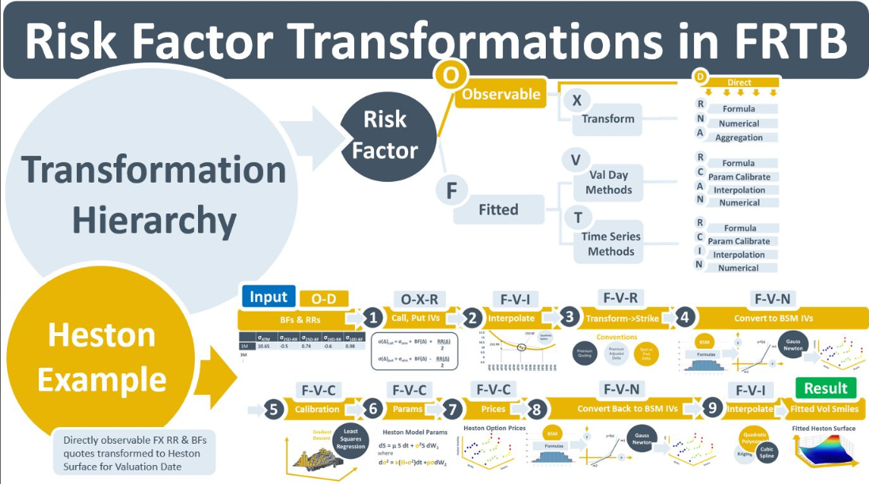

The FRTB RFET for Curves and Surfaces
In option pricing models a volatility surface is required to estimate the range of the option’s possible future cash flows. The yield curve is for discounting the cash flows to present value. The market rates for these data constructs are non-continuous and have missing data points. To generate smooth, continuous constructs, pricing and risk models use curve & surface fitting processes. Model parameters are optimized until the models generate continuous curves with the closest “fit” to the observed data. The parameters are deemed “calibrated” at the closest fit.
Calibrated parameters are used in two ways. The first is in front-office pricing models to generate daily valuations. The second is in market risk for simulating time series of daily returns for use in ES and VaR. Approximating or reduced-form models are sometimes used in market risk. The FRTB P&L Attribution test is designed to ensure differences between these two approaches are minimal.
For FRTB IMA, risk factors (RFs) need to be “modellable” under the RF eligibility test (RFET). Trades or quotes for options, known as real price observations (RPOs), need to be verifiably linkable to the portion or “bucket” of the vol surface deemed to impact the RPO’s valuation. For a fitted surface, it is the model’s parameters that need to be assessed for “modellability”. They are considered modellable if all the instruments on the source market data surface are in “modellable buckets”. The bucket or portion of the surface is modellable if the bank can demonstrate that it could plausibly reproduce the RPO valuation (the option’s price) if the bucket was used as input to the option pricing model.
Unlike VaR, ES and other traditional market risk requirements that have been re-configured for FRTB, the RFET is a completely new concept. Banks, data vendors, software providers and regulators are unsure how the RFET process will evolve as FRTB is rolled out. Like all new regulations, the RFET will be implemented tactically initially. Processes will be optimised and will mature. For example, the automation of linking RPOs to modellable RF buckets. Attribute matching, the use of risk sensitivity thresholds, and the re-valuation of RPOs using modellable RF buckets are all potential approaches. Data lineage will also be an important part of the RFET. Bank’s systems will need to be able to trace model parameters back to their calibrating instruments. These are complex and operationally challenging tasks.

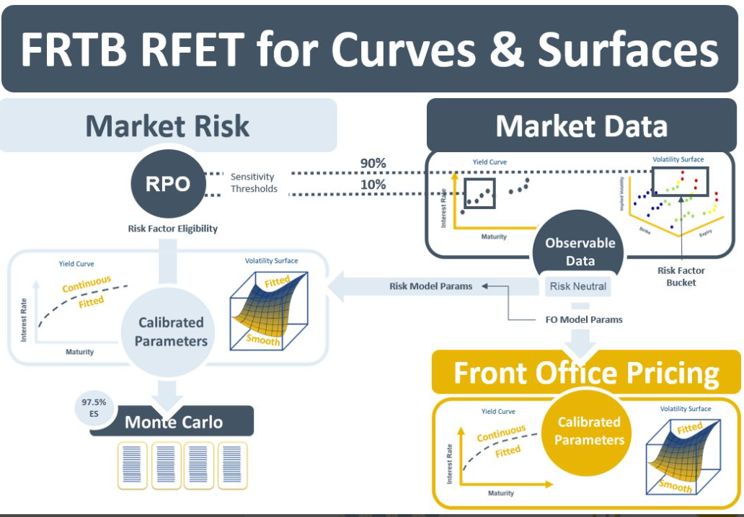

The Yield Curve and FRTB
Market risk is the risk of losses due to adverse movements in market prices. FRTB requires that a bank set aside a capital amount commensurate with the size of its exposure to market risk. A risk factor is a traded financial instrument or a curve built from a group of instruments that the bank is exposed to. The price changes in multiple-instrument RFs are highly correlated. A yield curve is an example of a multiple-instrument RF. The instruments that are used to build it, e.g., deposits, futures, swaps are all exposed to changes in an underlying index (e.g., ESTR, SONIA, EFFR or LIBOR3M). Each instrument has exposure to a different maturity segment. The YC is the most important RF in a trading book. Valuations of OTCs in all risk classes require the multiplication of expected future cash flows by discount factors that are extracted from the YC.
A RF is shocked to generate a theoretical $loss that is used as market risk capital. Under FRTB IMA, the shock is calculated using actual historical or simulated historical changes in RFs. Under FRTB SA, the shocks sizes are specified in the FRTB document. They are then applied to the bank’s exposures to those RFs, which are called risk sensitivities (RS). There are three sensitivity types - delta, curvature and vega - that exist across seven risk classes. The delta RS in the interest rate risk class is an exposure to changes in the YC.
There are two approaches for calculating RSs. Under the numerical approach they are generated by shocking the YC level or its volatility, and then re-running trade valuations. The resulting changes in valuations are the RSs associated with the YC. The second approach is analytical. Changes in e.g., a swaptions price over time can be modelled using partial differential equations (PDEs) that take the YC and its volatility as input. Delta, curvature and vega are the partial derivatives of PDEs and they can be calculated using formulas. RSs can be generated either by Market Risk systems directly or by trading desk systems and re-used by Market Risk.
More generally, trading desks typically use different models and market data than Market Risk. E.g., the desk might use a bootstrapping approach to build the YC because it re-prices its constituent instruments exactly. Versus the use of Nelson Siegel parameters by Market Risk because of the flexibility it offers for curve-building for different risk scenarios. In the area of volatility estimation, the Vasicek model might be used by traders because it can reproduce observed implied volatilities. Whereas Market Risk teams often use GARCH models to generate volatility in HistSim approaches.
In all cases, the P&L shocks generated by Market Risk need to be good approximations of the official P&L generated by the desk. The P&L Attribution test under IMA is designed to ensure that Market Risk approximations of historical P&Ls are sufficiently close to trading desk actual historical P&Ls.

